REQUIREMENTS FOR A CERTIFICATE OF ANALYSIS

REFERENCE: ISO 17025

Each Certificate of Analysis report shall include at least the following information:

- A title (e.g. Test Report” or “Certificate of Analysis”)

- The name and address of the laboratory, and the location where the tests were carried out, if different from the address of the laboratory

- Unique identification of the test report or Certificate of Analysis (such as serial number)

- The name and address of the client(if available)

- The test method used

- A description of the condition of and unambiguous identification of the product(s) tested which should include Batch/Lot number

- The date of receipt of the samples and the date of performance of the test

- The test results with, where appropriate, the units of measurement

- The name(s) function(s) and signature(s) or equivalent identification of person(s) authorizing the test report or Certificate of Analysis

- The name and signature of the laboratory analyst

NB

- Please note that the specific parameters for the Certificate of Analysis of any product should be in accordance with the Standard Specification for that product.

- All claims including nutrition information should be supported by analytical reports.

PLEASE FIND ATTACHED THE SAMPLE FORMAT OF A CERTIFICATE

OF ANALYSIS

N. B.

SHOULD BE ON THE LETTER HEAD OF THE LABORATORY
WHERE THE PRODUCT WAS ANALYSED

 |  |  | CERTIFICATE OF ANALYSIS |  |  |  |  |  |  |  | Serial No.
Date of Receipt of Sample:
Date of Performance of Test:
Sample Description:
Brand Name: |  |  |  |  |  | Production date:
Country of Origin: |  |  |  |  |  | Expiry date:
Net wt/volume: |  |  |  |  |  | Batch Number:
Packaging Type:
 |  |  |  | TEST RESULTS
PHYSICO-CHEMICAL ANALYSIS |  |  |  |  |  |  |  | DATE OF ANALYSIS :
PARAMETER |  |  | TEST METHOD |  |  |  |  | UNIT |  | SPECIFICATION/ |  |  | RESULTS
 |  |  |  |  |  |  |  |  |  | METHOD DETECTION
 |  |  |  |  |  |  |  |  |  | LIMIT
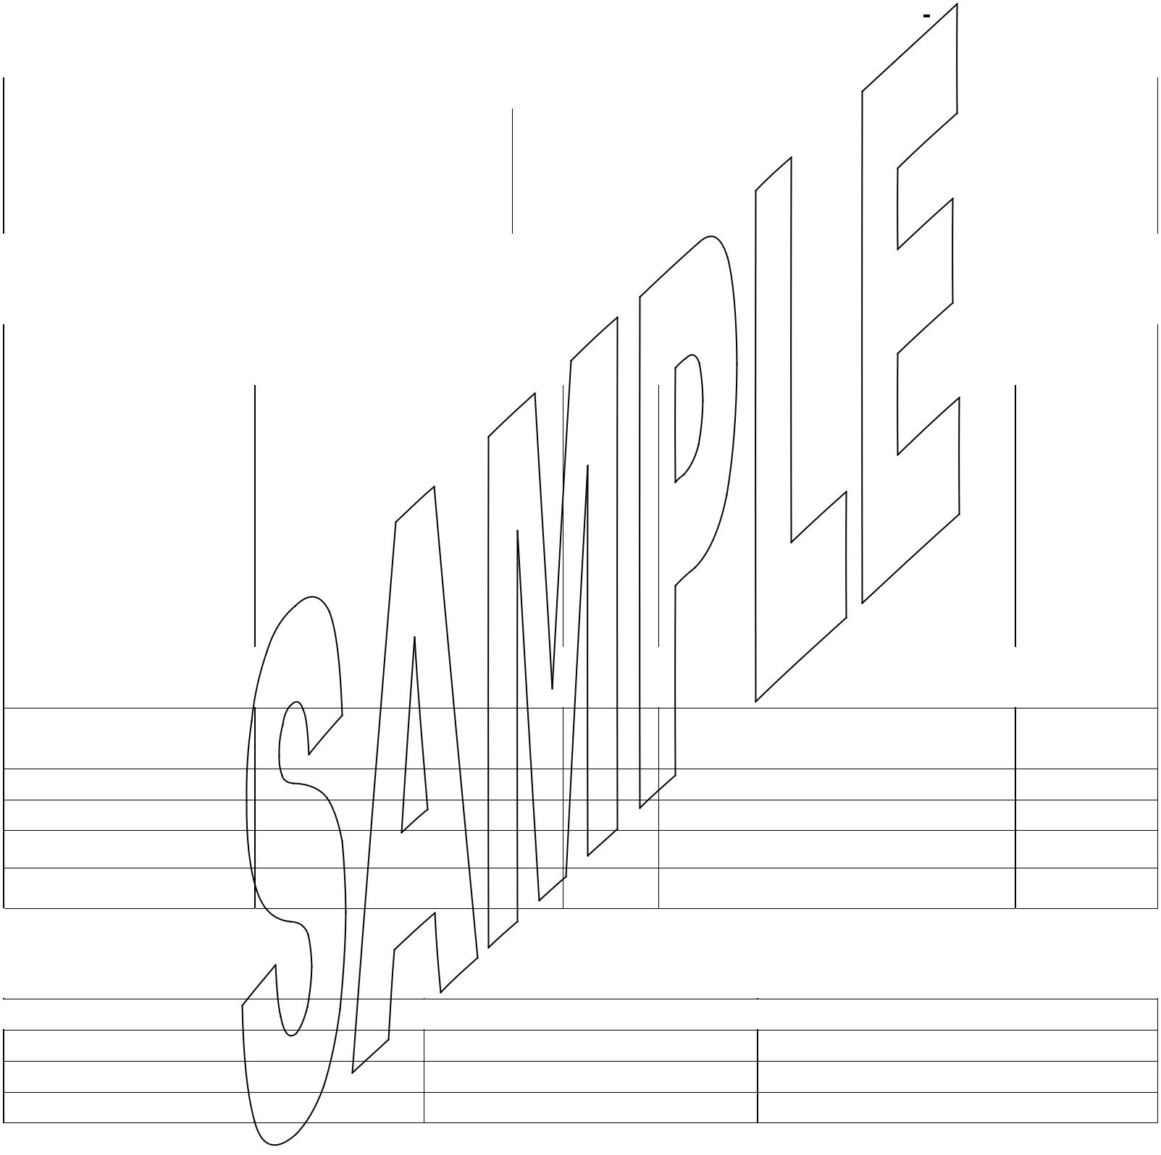MICROBIOLOGICAL ANALYSIS |  |  |  |  |  | DATE OF ANALYSIS :
PARAMETER | TEST METHOD |  |  |  |  | UNIT SPECIFICATION/METHOD RESULTS
 |  |  |  |  |  | DETECTION LIMIT

Remarks:

NUTRITIONAL INFORMATION
Nutritional Values e.g. per 100ml per serving size 1 can (250ml)

Authorized Laboratory Officer: Name:…………. Laboratory Analyst: Name:……….;

Signature:……………. Signature…………..

Designatory:………….

